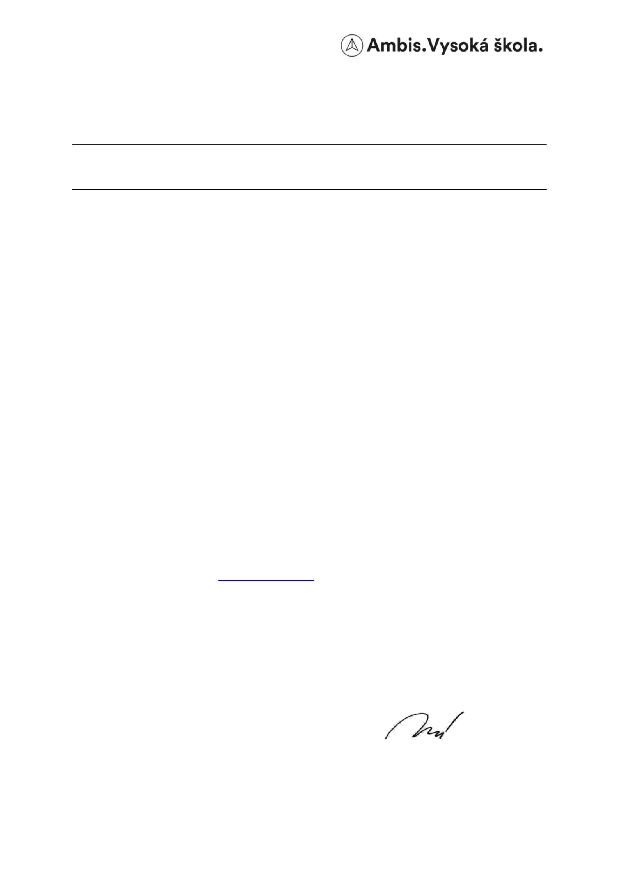

AMBIS Vysoká škola, a. s.

Lindnerova 575/1

Prague 8

RECTOR'SNOTICE No. 7/2023

Announcement of the Competition for the best publication achievement at AMBIS vysoká škola, a.s., for the year 2022.

The competition for the best publication achievement at AMBIS Vysoká škola, as (hereinafter referred to as "AMBIS University"), is carried out on the basis of the internal regulation VP-PR-06 Competition for the best publication achievement, with the aim of supporting the creative activity of academic staff and efforts to achieve excellent results in this area.

All academic staff of AMBIS University can participate in the competition. Every academic worker can submit their publication results to the competition, in two categories:

a. publication achievement,

b. usability of the results in teaching.

In the "publication effort" category , an academic worker can submit an article in which he has a part, published in a journal from the WoS or Scopus database, and this article (part in it) is listed in the RIV database for AMBIS University for the year 2022.

It is not possible to submit an article that was submitted to previous years of the competition.

Each academic worker can submit only 1 article.

In the category "usability of results in teaching", an academic worker of AMBIS University can submit any output according to Methodology 17+, which is listed in the RIV database for AMBIS University for the previous three years and of which he is the author or co-author and is used in teaching.

Send the application to e-mail: vyzkum@ambis.cz. If the result is not available on the Internet, send the registered result at the same time as the application.

The evaluation criteria are stated in the internal regulation "VP-PR-06 "Competition for the best publication achievement"

The deadline for submitting applications for the competition is 6/16/2023.

In Prague, on 18 May 2023

Dr. Martina Mannová

rector

8-5494-18.05.2023 Page 1 of 1

