

AMBIS University, a. s.

Lindnerova 575/1, 180 00 Prague 8 – Libeÿ

NOTIFICATION OF THE RECTOR No. 1/2023

Call for submission of projects within the Student

internal grant agency AMBIS Vysoká škola, a.s.

In accordance with the internal regulation VP-PR-01 Student Internal Grant Agency, I am announcing a competition within the Student Internal Grant Agency (hereinafter referred to as "SIGA") of AMBIS University, as (hereinafter referred to as "AMBIS VŠ") for the academic year 2022/23.

The goal of SIGA is to increase and support scientific research activities (including cooperation with practice) especially of students of follow-up master'sstudy programs in cooperation with academic staff, to support the publication of achieved results and to contribute to increasing the quality and efficiency of scientific, technical and educational work.

The solver can be:

- a student in the master'sdegree, in which case he must be the second solver (member researcher team) leader of the researcher'sdiploma thesis,

- an academic worker (who is authorized to supervise students'final theses), in which case at least one student of the master'sstudy program must be another member of the solving team (usually the one for which the given academic worker is the supervisor of the diploma thesis).
It is also possible that other students of the master'sor bachelor'sprogram are participating in the SIGA project, which is being solved by an academic worker, who are solving thematically similar problems in their final thesis, or are preparing to solve them.

In both cases, the above-mentioned academic worker is responsible for any withdrawal of funds.

Students must make up at least 50% of the solving team. The duration of solving student projects is a minimum of 1 year and a maximum of 3 years.

Students (in cooperation with their theses supervisors) carry out scientific research activities as part of the project:

a) in relation to your final thesis or b) in relation to

your final thesis and to projects of collaboration with practice (may have the character of contract research) or c) in relation to your final thesis

and research that is being solved by an academic worker (supervisor of diploma theses) ) involved in the SIGA project.

Academic staff who are interested in subsequently submitting a SIGA project will list thesis topics for the master's degree with a note that these topics will probably (if subsequently approved) be part of the SIGA project. The academic worker usually lists several similar topics that will be part of one SIGA project if students show interest in them.

Subsequently (after approval of the SIGA project), they can also invite bachelor students to the project.

8-5464-16.01.2023 Page 1 of 2

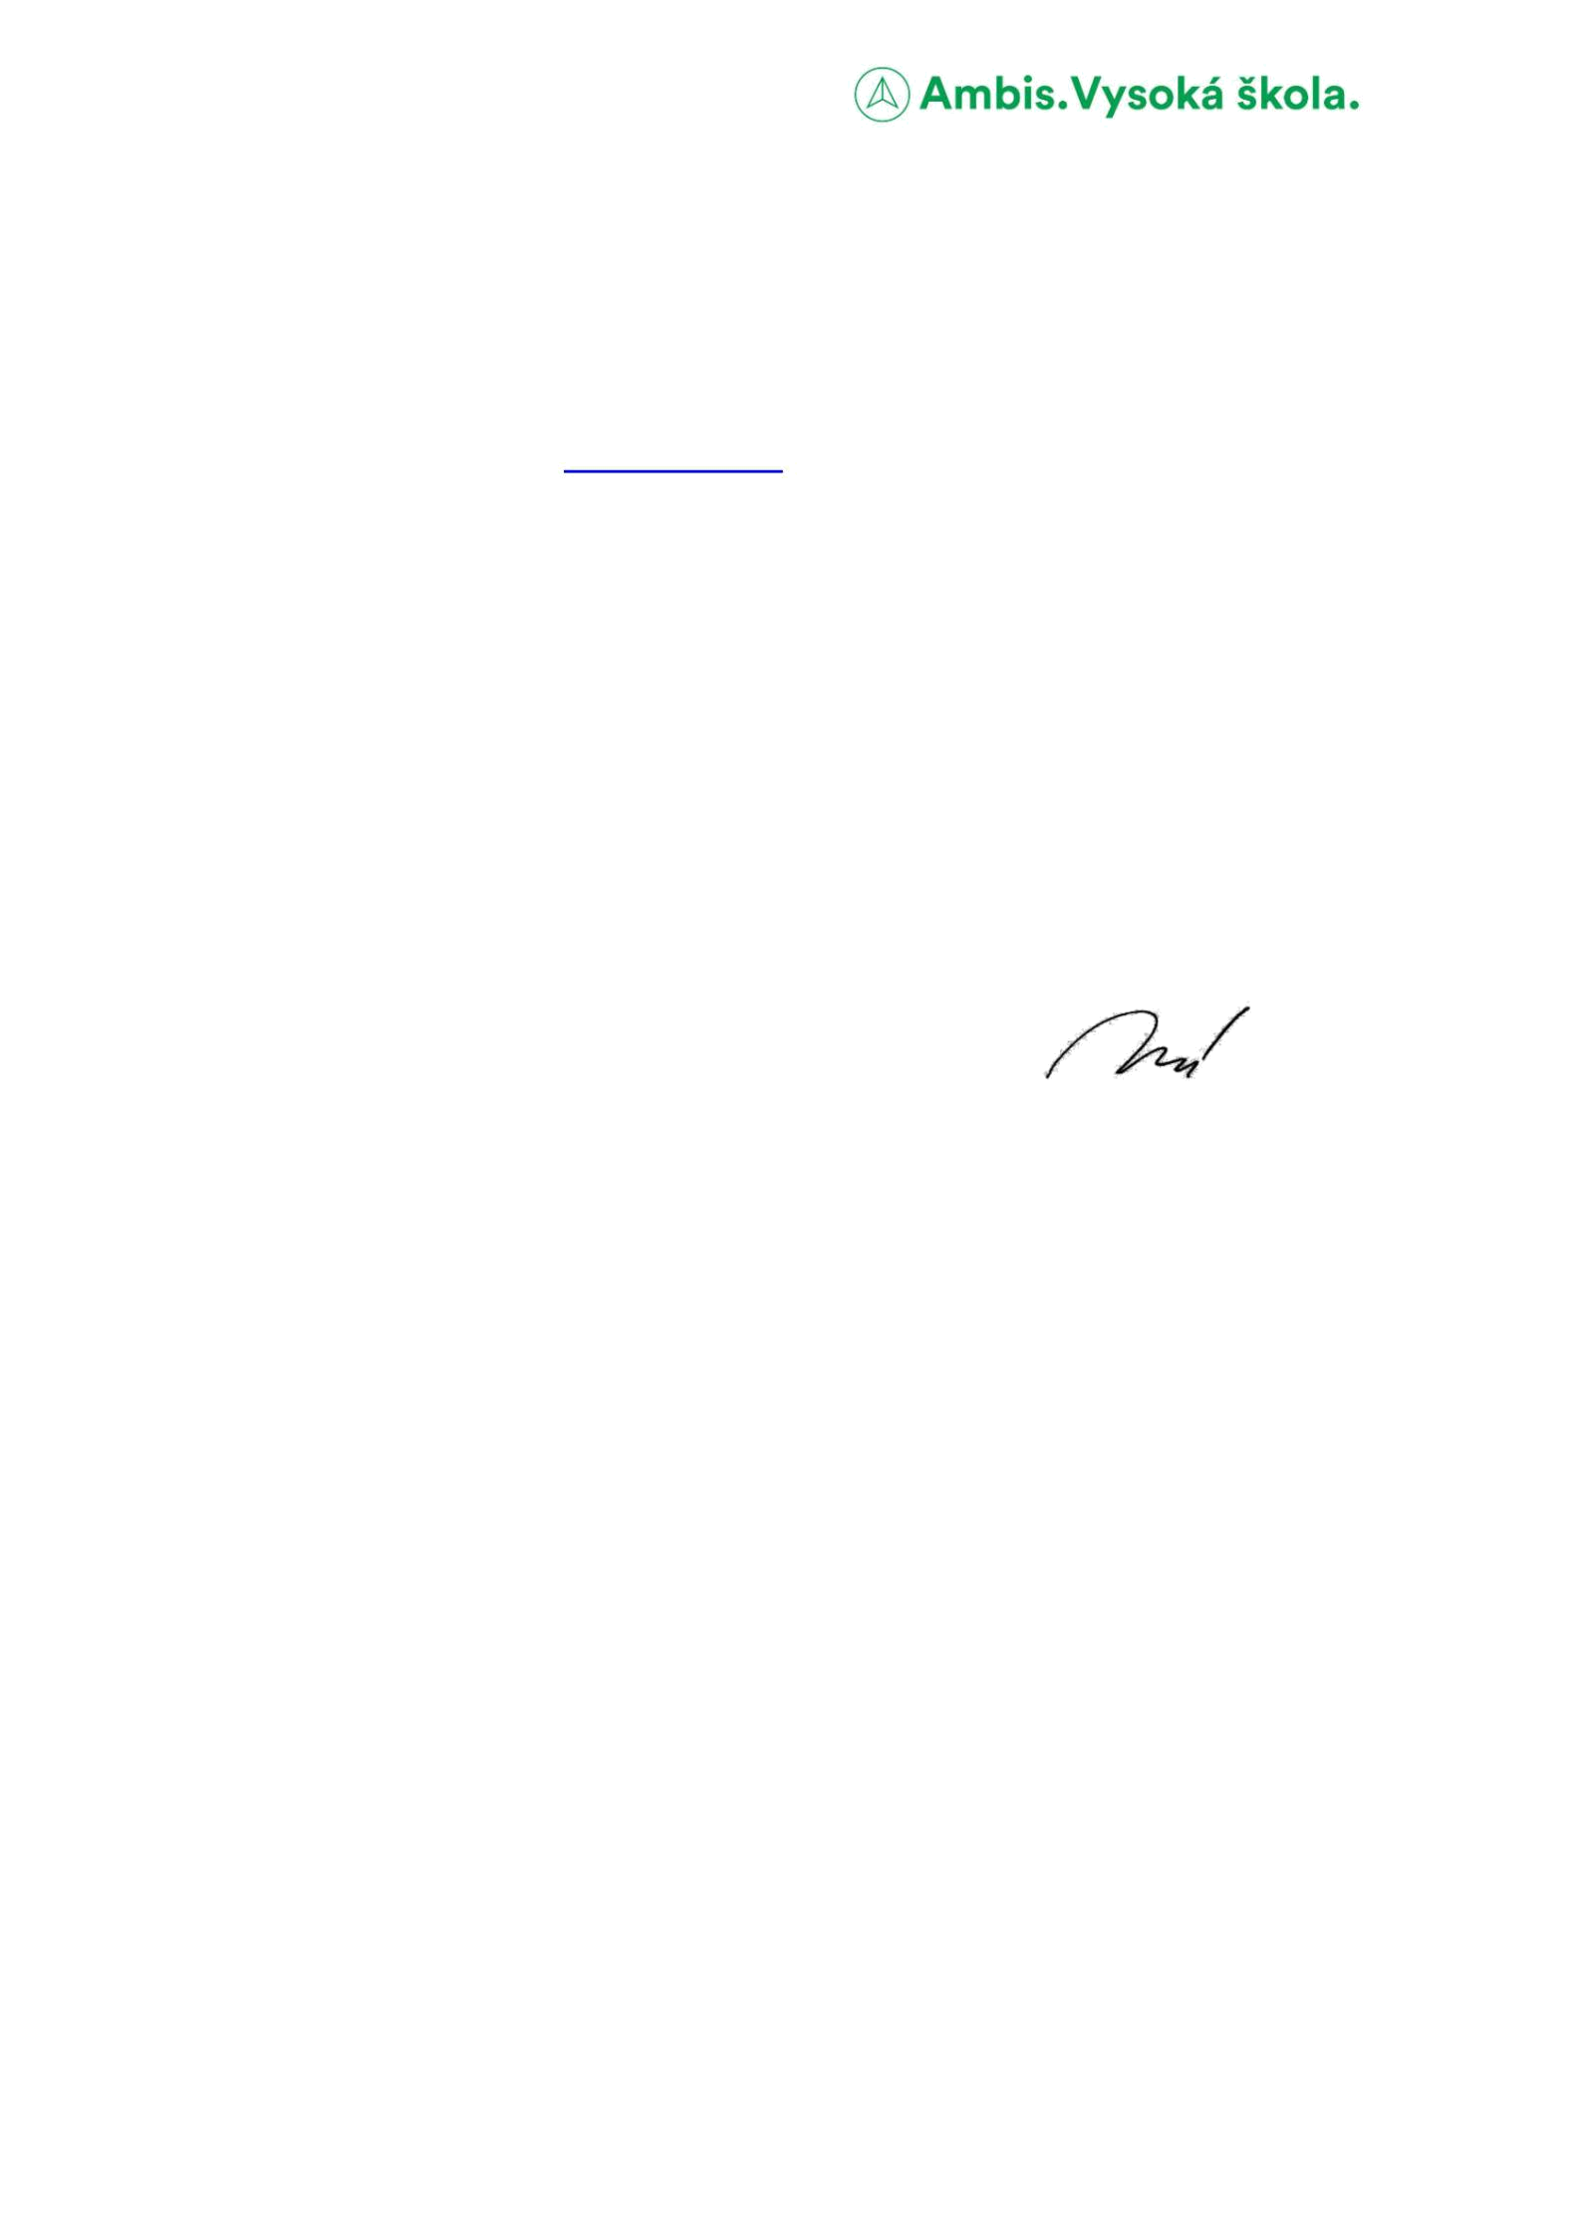

The expected outputs of the project are:

- results that are evaluated according to the valid methodology for evaluating the results of research organizations and correspond to the definitions of results for recording results in the RIV (for example, an article, a chapter in a specialist book, an exhibition, an audiovisual aid, a research report) or

- the expected outputs may also include the basis for these results.

The project proposal is submitted on the form, which is attachment No. 1 of this announcement, electronically to the Department for Science and Research at vyzkum@ambis.cz no later than 30 April 2023.

If current master'sstudents who are in their 2nd year of study are interested in submitting a SIGA project, they should immediately consult their supervisor, then the department for science and research.

In these cases, it is possible to submit the project this year, or at any time until 30.4. In this case, the project will start immediately after approval.

The list of projects recommended and not recommended for implementation is sent to the rector and the general director for comments.

_{In Prague on 17 January 2023} ---------------------------------------------

Dr. Martina Mannová

rector

8-5464-16.01.2023 Page 2 of 2

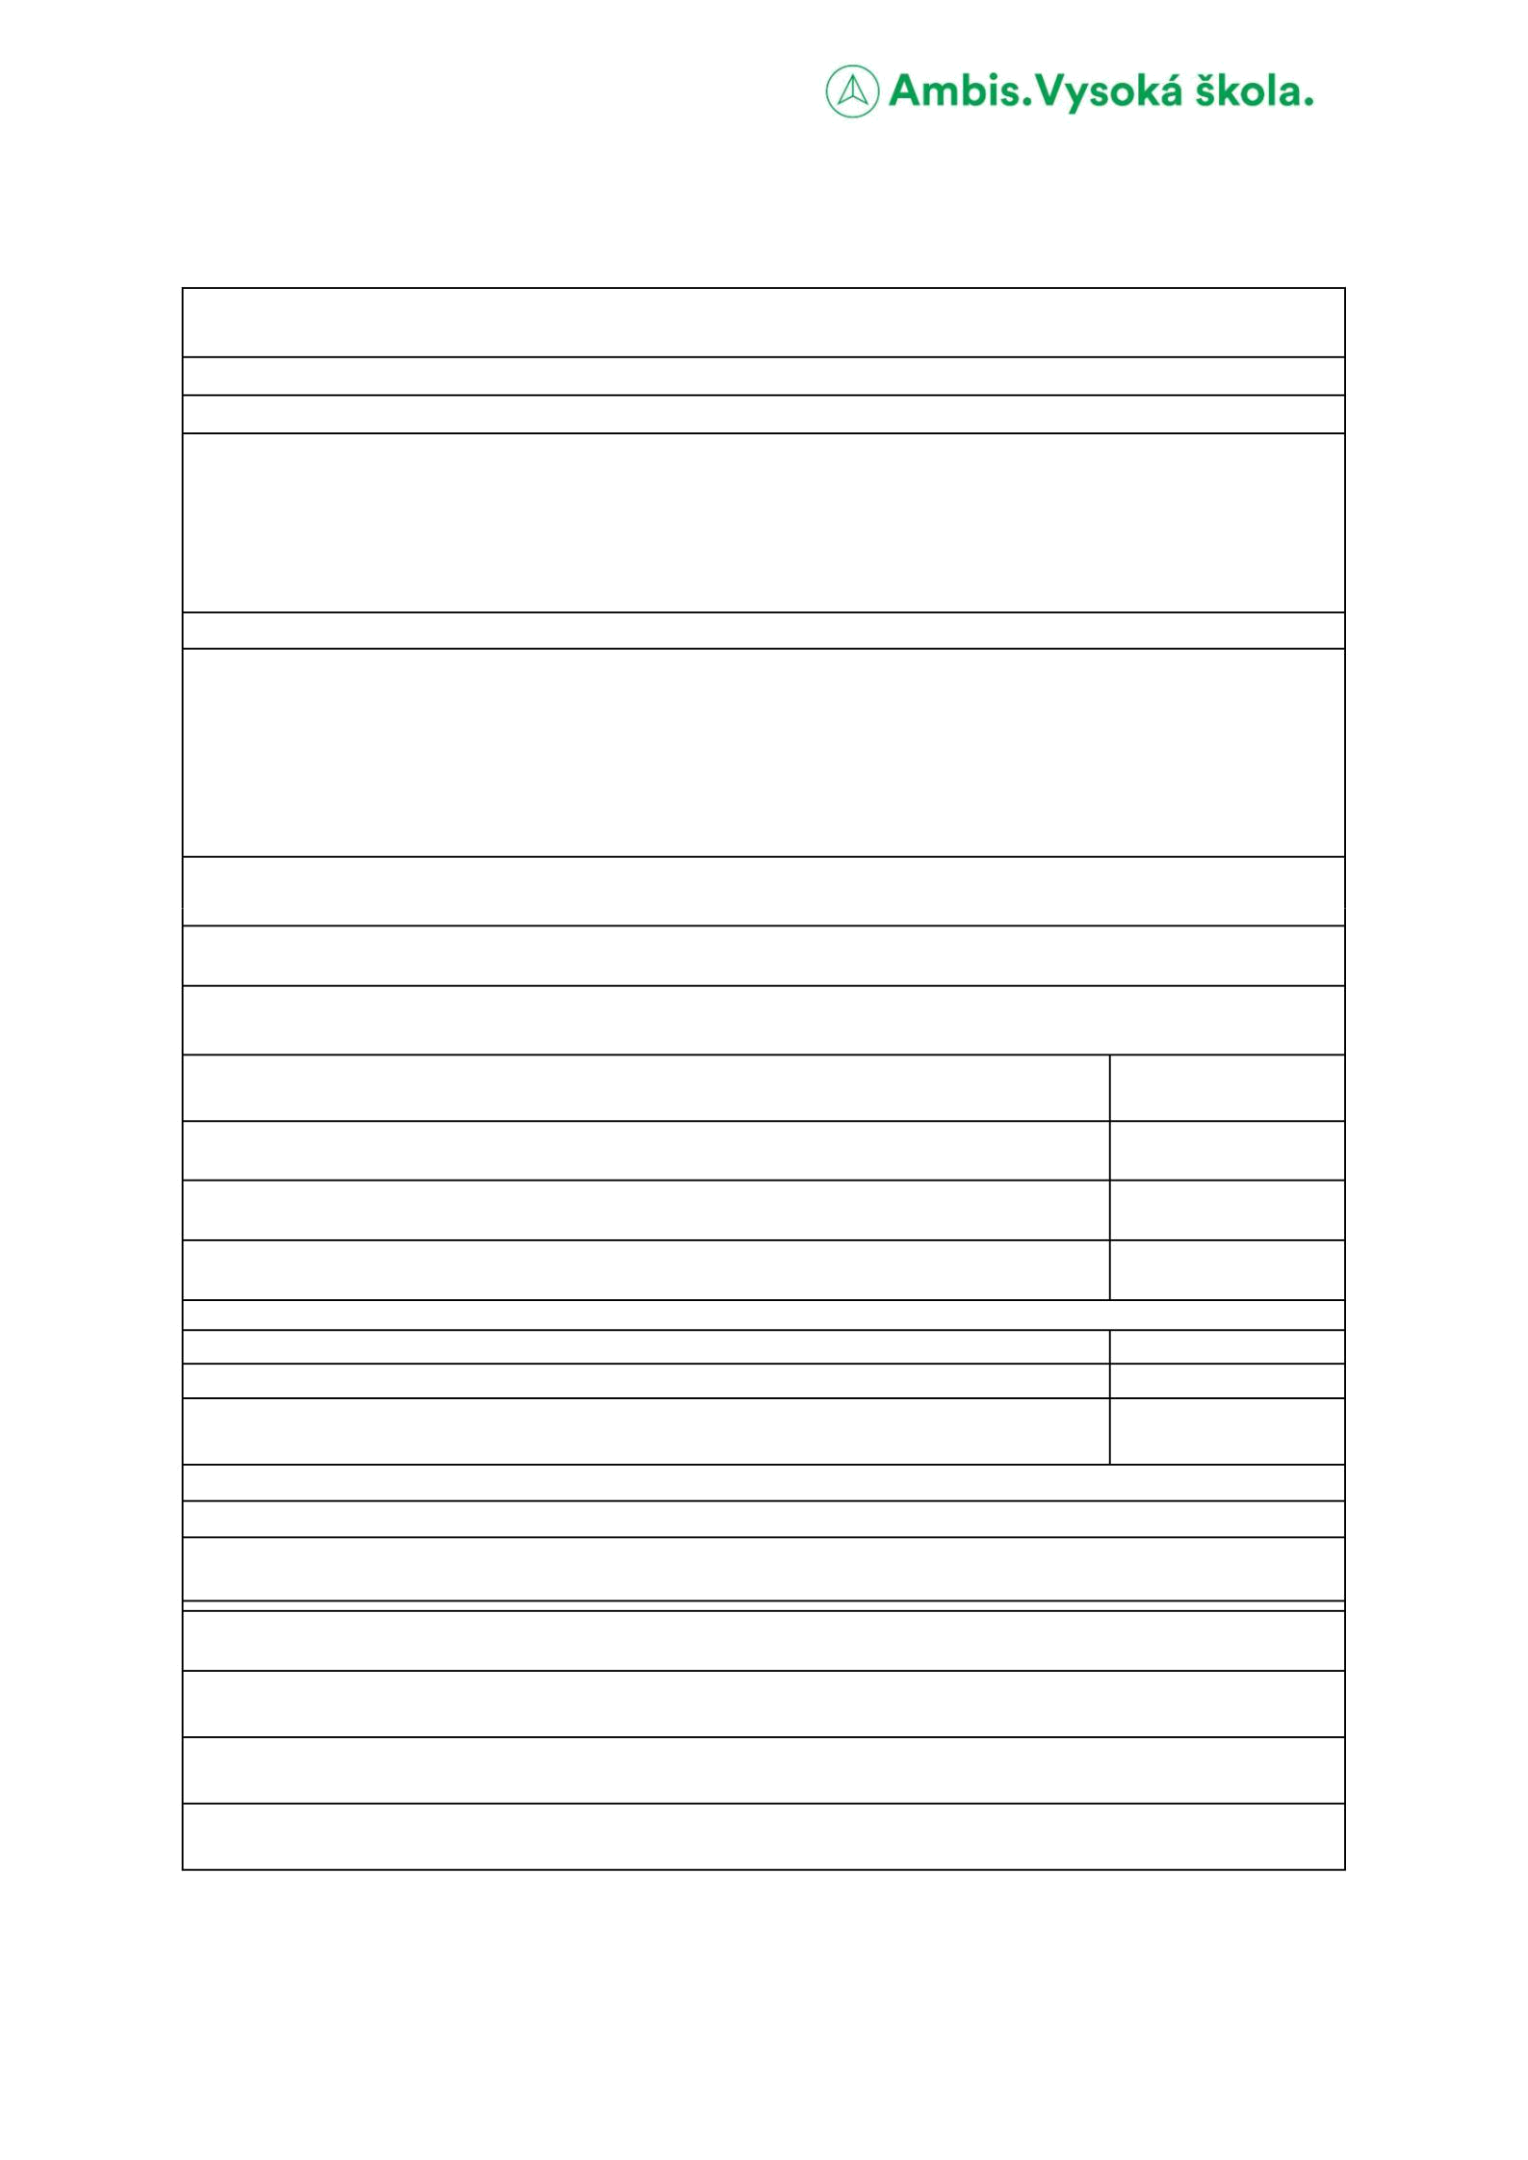

Annex No. 1 to VP-PR-01 SIGA project proposal

Name of the project (= topic of the SIGA project, which is based on the topic of the final thesis of the student researcher):

Project managers:

Name of the researcher - academic worker

Name of the researcher - master'sstudent:

Names of other involved academic staff or students, if known (more people may be involved; students must always be at least 50%):

Estimated project goal and number of project results (according to Methodology 17+):

The goal of the project is (describe the goal in about 2 sentences):

The results of the project will be (number and type of result according to Methodology 17+; if applicable, only provide the documents for these results, if relevant):

Duration of the project solution (anticipated start and end; minimum 1 year, maximum 3 years):

Launch:

End:

Data of the project budget (in CZK; if financial resources are not required, enter CZK 0 in the individual boxes; consult the budget in advance with R&D department staff): (a) service costs, which include mainly
editing costs, publication fees, translation costs (b ) personal expenses including
CZK
scholarships

CZK

(c) travel expenses, including conference fees

In total

It is necessary for the implementation of the project - mark yes/no (a) remuneration for the academic worker
(b) publication costs in magazines published by the school (c) costs

of using the school'sclassrooms for the implementation of project team meetings, workshops or conferences

CZK

CZK

yes/no

yes/no

Yes No

Additional information important for project approval (optional):

Name and signature of the academician (member of the research team):
Date:

Approval of the plan

The opinion of the head of the department (optional, a statement by e-mail is sufficient):

I recommend / I recommend with comments (write) / I do not recommend

Opinion of the vice-rector for R&D on the plan (an e-mail statement is enough)

I recommend / I recommend with comments (write) / I do not recommend

Approval of the plan by the rector (an expression by e-mail or at a management meeting is enough)

I approve / approve with comments / do not approve

8-5227-20. 10.2020

Page 1 of 1

